
Module 1: Atypical pneumonia – a call for understanding, action and reflection

Why has the spread of atypical pneumonia aroused intense response around the globe? Is it unprecedented? Is the damage beyond repair?

1

Case 1 | Case 2
Place: America | Place: Southern China
Time: 1520 to 1618 | Time: 2002 to 2003
Event:  The Spanish army had launched a colonial invasion into America, relying on advanced weapons to defeat the natives there. The Spanish killed many people.  But the diseases brought from Europe were more powerful than the Spanish firearms. It is estimated that between 1520 and 1618 smallpox alone reduced the Aztec population of Mexico from about 20 million people to 1.6 million. | Event:  According to the World Health Organization (WHO), the first case of atypical pneumonia was reported in Foshan in mid-November 2002. In late February 2003, a doctor from Guangzhou was staying in a hotel in Kowloon. He had been sick a week before and is considered the original source of the infection. He infected people staying on the same floor of the hotel and their visitors. The disease then spread to other parts of Hong Kong, to Singapore, Toronto in Canada and Hanoi in Vietnam.  As of 12 April, the disease has spread to 19 countries in Asia, Europe, North and South America. The number of reported probable cases is 2,960. The number of deaths is 119. (Please refer to the following map.)  [ The latest figures can be obtained  from the web site:  http://www.who.int/csr/sars/en/]
Possible cause:  Between 8,000 BC to 2,500 BC, people in Europe and Asia domesticated animals like cow, sheep, goat, pig and horse. From then on, the people developed resistance and immunity to diseases such as smallpox that arose from contact with the domesticated animals.  American native people, on the other hand, did not have enough time to develop resistance and immunity against diseases from Europe, and were largely wiped out. | Possible cause:  According to a report in the Far Eastern Economic Review (27 March 2003), a WHO team was invited by the Chinese Government to Beijing to determine if the Guangdong cases were caused by the H5N1 bird-flu virus. It was deemed to be unlikely.  Some researchers believe that most influenza outbreaks in recorded history originated in bird populations in southern China where humans and animals live in close contact. The diseases jumped from animals to humans.  With reference to atypical pneumonia, some Chinese experts on the mainland have concluded that the outbreak was caused by chlamydial organisms. The virus causing the disease is considered by the Chinese University of Hong Kong to be a member of the Paramyxoviridae family. Experts from the University of Hong Kong found that coronavirus is the primary cause of the disease.

Book review on Jared Diamond (1997), Guns, Germs, and Steel: The Fate of Human Societies
http://www1.dragonet.es/users/markbcki/diamond.htm

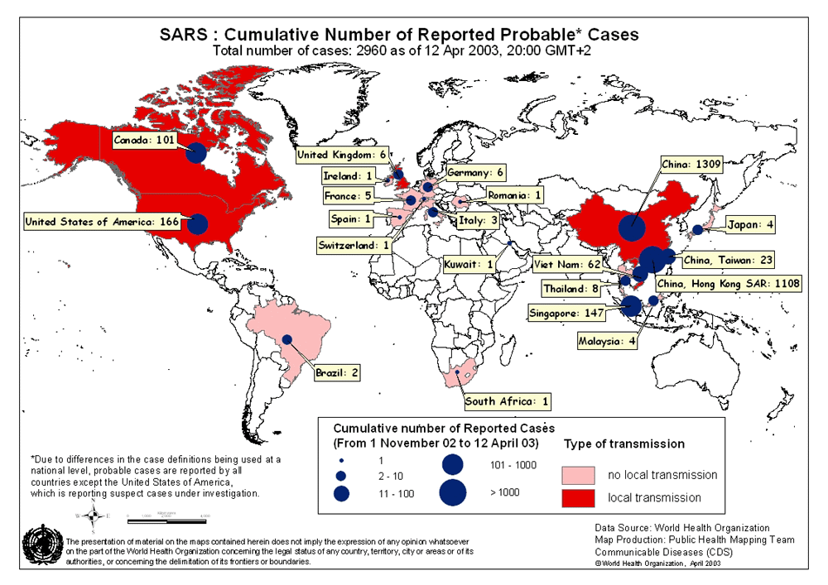
Source of information:
World Health Organization web site
(12 April 2003)
Activity 1 The court of neighbourhood opinion


- Is atypical pneumonia a new challenge to humans?
◻ Yes ◻ No ◻ No opinion

- Germ and virus jump from animals to humans. Is atypical pneumonia the first reported case in southern China?
◻ Yes ◻ No ◻ No opinion

- Were the Aztec helpless about the smallpox attack?
◻ Yes ◻ No ◻ No opinion

- Is Hong Kong helpless about the atypical pneumonia attack?
◻ Yes ◻ No ◻ No opinion

- Were the Spanish most responsible for the loss of many Aztec lives?
◻ Yes ◻ No ◻ No opinion

- Is Hong Kong most responsible for the outbreak and spread of atypical pneumonia?
◻ Yes ◻ No ◻ No opinion
Activity 2 compare and contrast


 | Case 1 | Case 2
Possible cause
Power to spread
Ways of spread
Power to kill
Extent and speed of spread to other parts of the world



Spanish Influenza

In the spring of 1918, there was an outbreak of a flu which was later named “Spanish Influenza”. It first started in a military camp in the USA. It spread to the war front in France in April, then to Spain. By the end of May, the Spanish king and most senior officers were infected. The disease further spread to Britain in June. It struck with amazing speed. Although the influenza itself did not cause the deaths, it caused pneumonia and heart disease which did cause the deaths. It has been estimated that throughout the world over 25 million people died of the influenza pandemic, an epidemic that is spread worldwide. The number of deaths from influenza was higher than those killed in the First World War. (The casualties of the First World War were about 8.5 million)

Translated from: http://home.kimo.com.tw/willylin2_tw/03-2-01.htm
Bubonic Plague (The Black Death)

The Bubonic Plague, more commonly referred to as the “Black Death,” ravaged Europe between the years 1347 and 1352. During this short period, 25 million people, one-third of Europe’s population, died.

The bubonic plague was spread by flea-infested rats. It is believed the plague originated in Asia. In October 1347, a Genoese fleet returning from the Black Sea, a key trade link with Asia, landed in Sicily and the disease was brought to Europe. It quickly spread north along the trade routes -- through Italy and across the European continent. By the following spring, it had reached as far north as England.

The bubonic plague causes fever and a painful swelling of the lymph glands called buboes, which is how it gets its name. It is also called the “Black Death” because it causes spots on the skin that are red at first and then turn black. During the plague, the disease struck and killed people with terrible speed. Thousands died and dead bodies littered the streets of Europe.

Translated from: http://www.northeast.com.cn/gjnews/200211080278.htm &
http://www.stdaily.com/big5/stdaily/2002-12/15/content_37654.htm

Activity 3 does history repeat itself?

- Is Hong Kong people facing a problem more serious than the Aztec did in the past? | Yes ◻ | No ◻
- Does virus only jump from animals to the Chinese? | Yes ◻ | No ◻
- Did the Spanish spread the disease to Aztec on purpose? | Yes ◻ | No ◻
- Do Hong Kong people spread the disease to other parts of the world on purpose? | Yes ◻ | No ◻

Does history repeat itself? Now that you know more about similar historical events, how do you feel? How does it help you understand the spread of atypical pneumonia?

Is atypical pneumonia a challenge only to human life and bad community hygiene? Are there any other worries? How can Hong Kong recover from the disease?

Virus Roaming, Delivery Express

1

Department of Health (DH) investigation has confirmed that seven persons affected by atypical pneumonia had stayed, or visited, a Kowloon Hotel in February, 2003.

Speaking at a press conference today (March 19), the Director of Health, Dr Margaret Chan, said the seven persons comprised three visitors from Singapore, two from Canada, one from the mainland and a local resident.

DH investigations revealed that the seven visitors had stayed on the same floor of the hotel between February 12 and March 2. They developed pneumonia symptoms between February 15 and 27. The local resident, who has been identified as the index patient in the outbreak at Prince of Wales Hospital, had visited a friend in the hotel from February 15 to 23. One of the seven, who had become sick one week before, is believed to be the source of the infection.

http://www.info.gov.hk/dh/ap.htm

2


A doctor from Guangzhou, who had become sick a week before, stayed at a hotel in Kowloon from 15 February to 23 February 2003.

Hotel guests and visitors on the same floor from12 February to 2 March 2003

One guest from Canada became ill and died after going back to Canada. Another became ill and stayed in a hospital in Canada. Many health-care workers were infected.


An American Chinese became ill when he visited Vietnam. He was sent back to Princess Margaret Hospital in Hong Kong. He later died there.
A local resident visited the hotel and became ill. He was sent to the Prince of Wales Hospital. Dozens of health-care workers were infected.


Three guests from Singapore became ill after they went back to Singapore. One started a chain reaction that left ill 50 family members and friends, along with 56 health-care workers
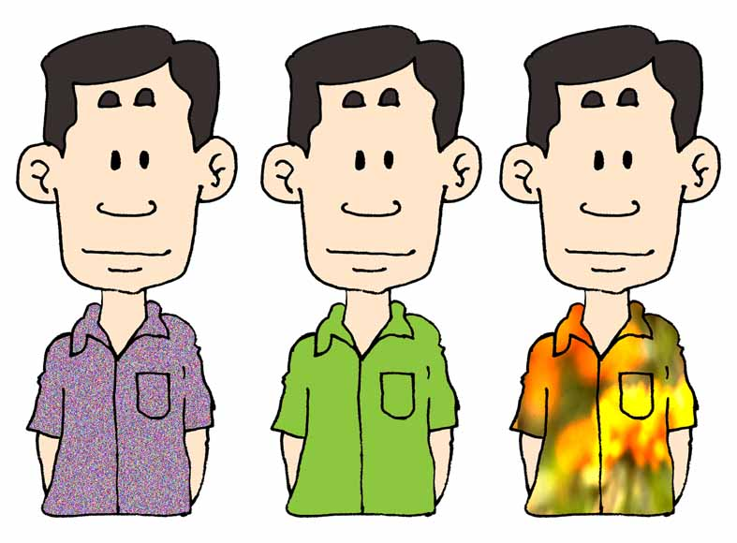.

- According to sources 1 and 2, from Hong Kong atypical pneumonia spread to many parts of the world within two months. Why can the virus roam the world in express speed?

- Atypical pneumonia has now spread to different countries and regions. Many of them seem to have achieved better control of the disease than Hong Kong. Why? What has been Hong Kong’s contribution of to this development?

3



International cooperation

The spread of atypical pneumonia can be better controlled through the cooperation of various regions, countries and international organizations. The following are the web sites of some related organizations:

World Health Organization http://www.who.int/csr/sars/en/
Ministry of Health, China http://www.moh.gov.cn/zhgl/zt/index.htm
Department of Health, http://www.info.gov.hk/dh/apc.htm
Hong Kong, China
Hospital Authority, http://www.ha.org.hk/sars/
Hong Kong, China
Centers for Disease Control http://www.cdc.gov/ncidod/sars/
and Prevention,
United States

- Is atypical pneumonia a global problem? Why?

- Can any individual country or region resolve this problem by itself? Why?

What is globalization? Is it a very difficult topic? Your answers to questions 1 to 4 have already brought out certain features of globalization.
Globalization has already led to many changes around us. The younger generations are in the frontline of globalization in many ways. For instance, you log onto the Internet every day, send ICQ and e-mail, talk over mobiles, dine in McDonald’s, drink Coke, wear T-shirts, jeans and Nike, use digital products, listen to MP3, watch films and TV shows from all over the world.


What is globalization?

Some people think that real globalization only began in mid-20th Century. Major features include the advancement of new technology (e.g. information technology and Internet), the establishment of a global economy, the emergence of global problems, and the rise of a sense of togetherness on a global scale.

There are different definitions of globalization. Here are some of them:

- Globalization refers to the interdependence of economic activities, in particular the free flow of capital across the boundaries of nation-states and the deployment of resources on a global scale.
- Globalization means a world made smaller by a stronger sense of human togetherness.
- Globalization refers to the process of the strengthening of social relationships. The process creates ties among different places in the world and events happening in these places mutually influence each other.

1

A few years ago, supporters of globalization in the West declared that a “global village” is emerging which would bring about global harmony. They thought that the advancement in information technology together with economic globalization would reduce the differences between political systems and cultures. There would be fewer conflicts and humanity would become closer than ever before. There would be equality between different ethnicities, classes and regions. The benefits of globalization could be shared by every one.

The Industrial Revolution and urbanization had divided the world. Society is full of conflicts. In contrast, in a global village one would find harmony and equality. There would be no strangers.

Abridged and translated from:
施鵬翔〈誰的國際都會? ― 全球化與香港的族群關係〉,《思》, Hong Kong: Hong Kong Christian Institute, No. 64, November 1999, p.6.

1. Do you agree with the ideals of the global village as described in source 1? Why?

- Do you see Hong Kong people as villagers of the global village? Why?

3
2
On 2 April 2003, an order of the Swiss Government effectively stopped Hong Kong exhibitors from doing business at the World Jewellery & Watch Fair 2003, which opened on April 3 in Basel and Zurich. The Swiss were concerned about possible transmission of atypical pneumonia at the fair. It was known that individuals from Hong Kong, the mainland, Singapore and Vietnam had been affected by the virus. It ruled that the fair organizer must ensure that exhibitors neither “employ nor engage” people who have been in those affected areas after 1 March, 2003.

Trade Development Council,
http://www.tdctrade.com/tdcnews/0304/03040201.htm



In April 2003, organisers of the Sister Cities Conference in Masterton, New Zealand, asked the 43 Chinese delegates to stay away from the conference because of fears they might transmit atypical pneumonia.

“The decision that was taken was driven not by advice from the Ministry of Health ... it was driven by perceptions, by fears, which were unfortunately uninformed,” New Zealand Foreign Affairs Minister Phil Goff said.

【A telephone message received by the Chinese Canadian National
Association in Canada, April 2003】
4
You people (Chinese) are living like rats and eat like pigs, and spread the dirty, dirty deadly disease (atypical pneumonia) around the world.

- After the outbreak of atypical pneumonia, the relationship between Hong Kong people and other villagers in the “global village” underwent some changes? How do you feel about the changes?

- In your opinion, is the idea of the global village only an ideal? Why?

- What should Hong Kong do in order to stay in the “global village”? How can you help Hong Kong achieve that?
