Module 3 : Issues encountered in a time of Crisis

A : A Typical Family under Atypical Pneumonia

Every Hong Kong citizen is going through a hard time coping with the threat of Atypical Pneumonia. Here is the Chan family. Image you were one of them, what would you do?

Role-play with four other classmates. The five of you make up the Chan family.

Background information：

Mr. Chan (Father): A senior official of the Department of Health, HKSAR, living with his wife and children in Shatin.
Mrs. Chan (Mother): Housewife.

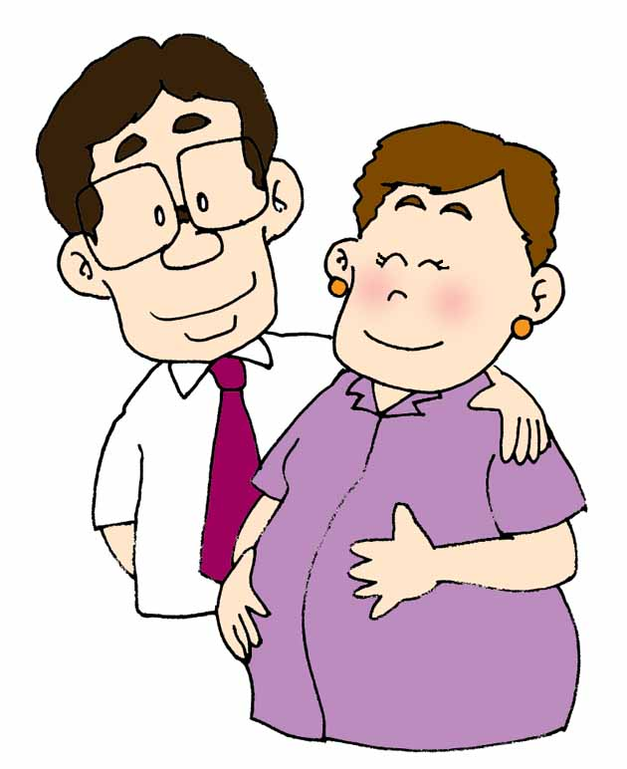

May (Daughter): A nurse at the Prince of Wales Hospital, Shatin.
David (Eldest son): An officer in a bank. He lives in Amoy Garden with his pregnant wife.



Tommy (Son): A secondary three student in a Shatin school.
Case 1
Here is Tommy’s diary …

19th March (Wednesday)
The number of AP cases totals 150 today, most are said to be in the Prince of Wales Hospital. In my class, there are three absentees. Several of those who are present cough rather severely.

24th March (Monday)
The number of AP cases has risen to 260. It seems that the whole city is panicking. Many schoolmates are absent today. Even my class mistress is on sick leave. I feel scared whenever I pass by the Prince of Wales Hospital.

Diary

Diary

Diary
25th March (Tuesday)
There seems to be no signs of stopping. Today the city records 286 AP cases. Almost 100 schoolmates do not go to school today! Mom says I will have to stop going to school myself if there is no official suspension of classes.
27th March (Thursday)

Should I go to school or not?
Diary

Discussion:
If you were Tommy, would you go to school or not? Ask your family to give their opinions. (Family members are reminded that their opinions should be supported with reasons.)

Case 2

An unknown virus is spreading among the staff working in the Prince of Wales Hospital. Nearly 80 people including medical staff (of which more than 20 were in the medical ward on the 8th floor) were indeed attacked by the unknown virus. They are showing symptoms of fever and upper respiratory system infection and one now is on sick leave. Three had to be confined in hospital. Two have been confirmed to have contracted Atypical Pneumonia.
XX Post 12-3-2003

Daughter, many medical staff are infected. You should take two weeks off and leave that dangerous place. You know, you might pass on the virus to us. I am so worried.

Mom, I am scared of being infected too, but leaving will only increase the workload of other staff. I really don’t want to leave at this critical moment!

Discussion:
If you were May, what would you do? What factors would you take into consideration?
If you were one of the family members, would you support May? Why?
If you were May, what would you do to make your family feel less worried? Please be specific.

Case 3
By 17th March, more than 100 people are already confined to the Prince of Wales Hospital because of Atypical Pneumonia. People living in Shatin are very worried. The Chan family is having dinner while watching the news. The situation at the Prince of Wales Hospital makes the headline. Everyone is paying close attention.

The Secretary of Health, Welfare and Food Bureau, E.K. Yeoh, first admitted the number of Atypical Pneumonia cases in Hong Kong was shocking with most of them occurring at the Prince of Wales Hospital (PWH). Some doctors in PWH said it was the main source of the virus. They suggested the proper way was to close the Hospital temporarily in order to stop the spread of the virus. The Chairman of the Department of Medicine and Therapeutics of the Chinese University of Hong Kong, Professor Joseph Sung, said it would be easier to treat the cases by closing the Hospital but this does not mean the problem is solved.

Susanna Chu, XXX News

After watching the news report, different opinions are expressed by the Chan family members about the AP issue. One even suggests sending a letter to the District Board and demand the Prince of Wales Hospital to stop its services completely.
Discussion:
If you were a member of the Chan family, do you think the Prince of Wales Hospital should stop its services completely? (Think about the following issues)
What good will it do if the Prince of Wales Hospital closes?
What price has to be paid?
What about emergency cases? Where should the patients go?
Can the closure of the Prince of Wales Hospital effectively stop the spread of diseases in the community?


Case 4

At about 9 p.m. on 30th March, the Chan family is watching the news report on the outbreak of Atypical Pneumonia at Amoy Garden. More than 80 infected cases are reported, with 70% of them living in Block E. The Government has announced that Block E would be isolated for 10 days. The Chan family is so worried because their eldest son, David, is living in Block F and his wife is five-month pregnant. There would be serious consequences on the unborn baby if one of the parents is infected. Mrs. Chan intends to call his son. The doorbell suddenly rings. It is their son and daughter-in-law with their luggage……

You are here? We are so worried about you!
Discussion:
Do you think the Chan family should let David and his wife stay in their flat? (Refer to the appendix)
What do they need to consider when making the decision?
Mom and Dad, please let us stay here. We have nowhere to go! The whole of Amoy Garden is filled with virus. We are so scared. Block E will be isolated from tomorrow onwards. I don’t know when it will be our turn! We will lose our baby if we are infected…We don’t know what to do. Please save our baby!

Case 5
It is about eleven in the morning of 1st April. Only the mother (Mrs. Chan) and the little brother (Tommy) are at home. The phone rings and Mrs. Chan picks up the phone at once.
Hello! Aunt. You’d better hurry to the supermarket to stock up. This morning, I am told that Hong Kong will be declared an infected port. Tomorrow, there would not be any food coming into Hong Kong. If you don’t stock up now, you would go without food. Quick! I have to phone other friends. Bye!!

Mary

Mrs. Chan is now very anxious and she calls her husband immediately.

My dear, you need not be so nervous. I do not think this is official government announcement. Don’t take the rumor seriously.
Dear, your cousin Mary just said that Hong Kong has become an infected port. She told me to go to the supermarket to stock up. What should I do?

Okay. Maybe I should call May and David up and see what they think about it.

Discussion：
If you were Mrs. Chan, how would you check rumor?
As a member of the Chan family, what kind of advice you would give Mrs. Chan?
What is likely to be Mrs. Chan’s final decision?

【Appendix】
Tips for Making Decisions

When we have to make decisions, we could use a series of steps to reach the right decision. Let us now use Case 4 as an example to illustrate what steps one should go through when making decisions.

••••
•
•
••
•
Shall we let David and his wife stay in our flat?
How to make decision?
Let them stay
Do not let them stay
What to Consider?
Pros
David and his wife could feel secure/ comfortable

Cons

Pros

Cons

We would ／would not let them stay in our flat.
Problems Identified

Tips for Making Decisions (1)

Tips for Making Decision (2)
Problem Identified
Shall we let David and his wife stay in our flat?
Step 1

Alternatives
Step 2
Let them stay

Pros & Cons of each choice
Step 3
Pros ：
Pros ：

Pros ：

Cons ：
Cons ：

Cons ：

Our Decision
Step 4

抉擇小錦囊 3
Tips for Making Decision (3)
 | Problem : Shall we let David and his wife stay in our flat?
 | Decision  Factors for  consideration | A : Let them stay | B : | C :
- Feasibility
（Is it easy to be carried out?）
【5 marks：easiest】
【1 mark：most difficult】
 | - Pros
 | - Cons
 | - Possible Outcomes

Our final decision

We have decided to ________________________, it is because__________________________________.

