Geography for Junior Forms –  The spatial distribution of Atypical Pneumonia | 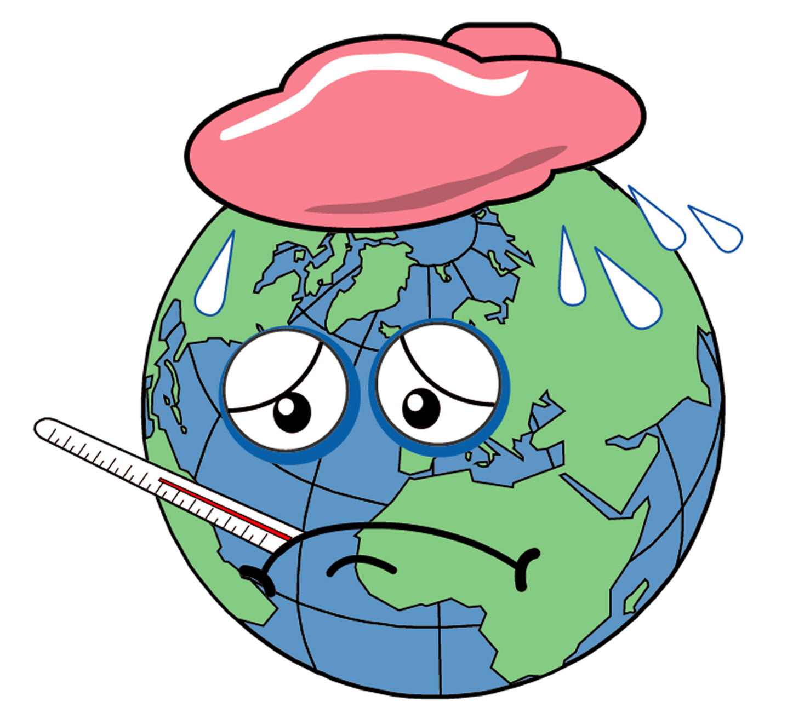

The Whole World in Panic –
SARS is endangering the life of everybody

Besides the war in Iraq, the recent outbreak of Atypical Pneumonia (SARS) has caught the whole world’s attention. Let us take a look at what’s happening!

A. SARS Outbreak in China

Table 1 shows the number of SARS cases reported in China by 18 April, 2003. Based on this information, answer the following questions.

Table 1

Province / Municipality | No. of cases | Provincial capital
Beijing | 339 | -
Fujian | 3 | (a)
Guangdong | 1304 | Guangzhou
Guangxi Zhuangzu Zizhiqu | 12 | (b)
Henan | 2 | (c)
Hunan | 6 | (d)
Nei Mongol Zizhiqu | 25 | (e)
Ningxia Huizu Zizhiqu | 1 | (f)
Shanghai | 2 | -
Shanxi | 108 | (g)
Sichuan | 5 | (h)
Source: http://www.cctv.com.cn/news/china/20030420/100371.shtml

- With the help of an atlas, find the provincial capitals of the provinces mentioned.

(a) |  | (c)
(b) |  | (d)
(e) |  | (f)
(g) |  | (h)

- Mark the required provinces, provincial capitals and municipalities on the map provided.

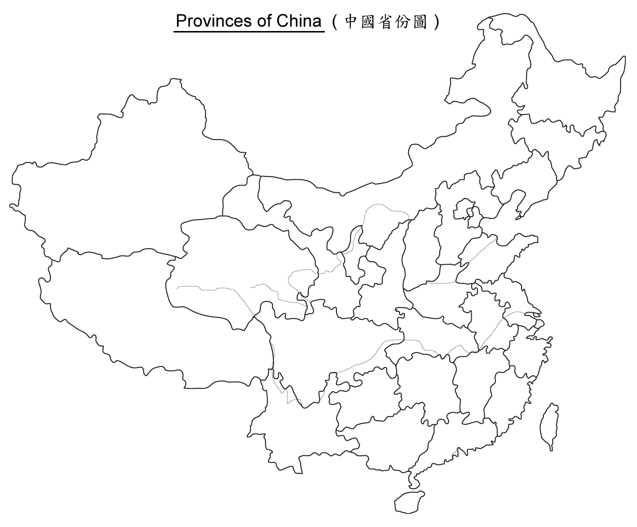
Scale 1 : 34,100,000

- How dispersed is the spread of SARS reported cases in China?
(Hints: concentrated / dispersed)

- What directions are these provincial capitals and municipalities in relation to Hong Kong? Calculate their direct distance.

Provincial capital or municipality | Compass point | Whole-circle bearing | Direct distance
Beijing
(a)
Guangzhou
(b)
(c)
(d)
(e)
(f)
Shanghai
(g)
(h)

- Is there a relationship between the distances of these places from Hong Kong and the number of cases reported.
a. There is little relationship. □
b. There are some relationship.
i. The shorter the distance, the higher the number of cases and vice versa. □
ii. The shorter the distance, the lower the number of cases and vice versa. □

B. SARS Outbreak in the world

Table 2 shows the number of reported SARS cases in different areas of the world.

Table 2
Country / City | Date
Country / City | 17/3/03* | 24/3/03* | 4/4/03# | 19/4/03#
Australia | - | - | 1 | 3
Belgium | - | - | 1 | -
Brazil | - | - | 1 | 2
Canada | 8 | 11 | 69 | 132
China | + | + | 1220 | 1512
China, Hong Kong SAR | 95 | 260 | 761 | 1358
China, Taiwan | - | 6 | 15 | 29
France | - | 1 | 3 | 5
Germany | 1 | 4 | 5 | 6
India | - | - | - | 1
Indonesia | - | - | - | 1
Italy | - | 2 | 3 | 3
Japan | - | - | - | 4
Kuwait | - | - | - | 1
Malaysia | - | - | - | 5
Mongolia | - | - | - | 3
Philippines | - | - | - | 1
Republic of Ireland | - | 1 | 1 | 1
Romania | - | - | 1 | 1
Singapore | 20 | 65 | 100 | 177
South Africa | - | - | - | 1
Spain | - | 1 | 1 | 1
Sweden | - | - | - | 3
Switzerland | 2 | 2 | 2 | 1
Thailand | 1 | 5 | 7 | 7
United Kingdom | - | 3 | 3 | 6
USA | - | 37@ | 100@ | 220
Vietnam | 40 | 58 | 59 | 63
Total | 167 | 456 | 2353 | 3547
Source：http://www.who.int/csr/sarscountry/

Remarks:
- The number of cases changes over time. Cases will be counted if patients show certain symptoms. Previous reported cases will be discarded if further investigation proves that the person is not infected by SARS.
- *As of 1 February 2003.
- # As of 1 November 2002.
- + The information on China is still being updated.
- @ inclusive of suspected cases.

Study Table 2.

- According to the data on 19 April, 2003, identify the continents these countries and city belong to.

Asia

Europe

Africa

North America

South America

Oceania

Antarctica

- Name six countries or city which have the greatest number of reported cases on 19 April. Draw appropriate graph to show the changes in the number of cases from 17 March to 19 April.

- According to Table 2 and the graph that you have drawn, describe the extent of the spread of this disease.

- How dispersed is the spread of reported SARS cases in the world?

Read the following newspaper items of 8 April, 2003 and answer the questions below.

A SARS case was reported in Vancouver, Canada. The patient is a 48 years-old resident who is an immigrant from Hong Kong. He has gone to Hong Kong and was back 3-4 days ago. He has been staying in Amoy Garden during his stay in Hong Kong……

A suspected SARS case has been reported in Russia. The one infected is a Russian sailor who has just returned from Harbin in China……

Since Easter is coming, many students who have gone to study in the UK have gone back to Hong Kong for the holiday. Some schools in the UK have adopted a “segregation policy” which requires students from Hong Kong to stay in quarantine for 7 days after their return to the UK……

Another SARS case has been reported. The patient is a passenger who flew from Beijing to Hong Kong on the Dragon Air KA901 last Wednesday. He showed some SARS symptoms during his stay in Beijing. The Health Department announced that the 238 passengers on that same flight should report to the department for investigation……

- According to the information provided by the above newspaper items, what are the possible ways that SARS can be spread.

- Bringing together information from Parts A, B and C, can you describe and explain in general terms the relationship between the spatial distribution of SARS and how it can be spread?

