
Typical "Atypical" E-mail
Believe it or not?!

Background
Recently, SARS rages in Hong Kong. Everyday we receive abundant information on SARS not only from mass media like television and newspapers, but also from other channels such as the e-mail. It is the e-mail that we, the youth, tend to use most often to receive "atypical" information.

It is really not an exaggeration to "crown" the e-mail as the single most important instrument for disseminating "atypical" information. From the e-mail, we receive information with no or little source reference and of doubtful content. But at the same time, it is also astounding hearsay which interests us most. More importantly, not all the information from the e-mail is untrue. If we take the information on its surface value, it will probably lead to trouble. At its best, the e-mail might just cause embarrassment. At its worst, it may lead to fear and anxiety, and turmoil in society as in the case of a 14-year-old student spreading rumour on the net that the HKSAR has been declared an infected city.

To assess the credibility of a piece of information is not an easy task. Credibility is influenced by many factors. Some information is deliberately made up to achieve certain purposes; some loses genuineness when the information is passed on from person to person. There are some basic criteria which can help us assess the credibility of certain information on the net.

Five Criteria in Assessing E-mail Credibility

- Date: Is the date clearly stated to indicate the time the incident took place? Is the date in line with other related events?
- The author: Who wrote this? Is he/she reliable? Does the information show any inconsistency(ies) with the author’s status, professional position and/or character?
- Purpose: What is/are the purpose(s) of composing the mail? Is it part of his job?
- Audience: Who is the target audience?
- Consistency: Do you find any inconsistency in the information？

（N.B.: In order to preserve the originality of the e-mails, grammatical errors and/or errors in sentence structure are not corrected.）
Below are excerpts from recent internet mails. Please discuss if they contain reliable information.

www.sosick.org
最新香港非典型肺炎受感染之地區 (截至03年4月2日8時00分)
Latest SARS Infected Area in HK (as of 2003.04.02 8:00am)

醫院 Hospitals
香港區 Hong Kong Island
1 XXXX醫院 XXXXXX Hospital
2 XXXXX Hospital…

Source 1

Source 2

真人真事, 不可忽視......... > > > 今日我家姐話我知(佢係威院o既醫生), 而家威爾斯o既情況同新聞講o既有好大差 距 > ... > > 我地會以為D記者渲染得好勁, 但係原來事實正好相反.. > > 有幾個威爾斯o既醫護人員已經接近死亡(其中有兩個係我家姐o既同事……

證實已染SARS的醫生名單
Dr Name 姓名 地址
Axx Axx Axx 甲xx 甲xx 甲xx 上水xxxxxxxxxxxxx
Bxx Bxx Bxx 乙xx 乙xx 乙xx 中環xxxxxxxxxxxxx
Cxx Cxx Cxx 丙xx 丙xx 丙xx 土瓜灣xxxxxxxxxxx
Dxx Dxx Dxx 丁xx 丁xx 丁xx 九龍灣xxxxxxxxxxx
Exx Exx Exx 戊xx 戊xx 戊xx 石硤尾xxxxxxxxxxx
Fxx Fxx Fxx 己xx 己xx 己xx 元朗xxxxxxxxxxxxx
Gxx Gxx Gxx 庚xx 庚xx 庚xx 大嶼山xxxxxxxxxxxx
Source 3

我同學昨晚(28/3)漏夜打電話來,說她朋友的弟弟剛從xx工幹回來,在電話中告 訴 她,其實他還未工幹完,而是冒著被炒的危險回來,因為xx死了很多人,在他工作附近的一條村,差不多成村人瓜晒,但消息封鎖,死都唔俾人知係肺炎,仲立刻將屍體即時燒掉,意圖毀屍滅蹟……
Source 4
Source 5
威爾斯醫院有一位肺炎危殆的病人曾於旺角xxxx唱K, 現場 其餘都中招,情況嚴重!!!請大家傳開去.

Source 6

Tony Mok >>Prince of Wales Hospital >>Chinese University of Hong Kong

I AM at Prince of Wales every day, closely involved with all actions and still in good shape. Let me clarify the subject matter:
There is no evidence that the infection is airborne.
Only direct exposure to respiratory droplet has been related to infection…

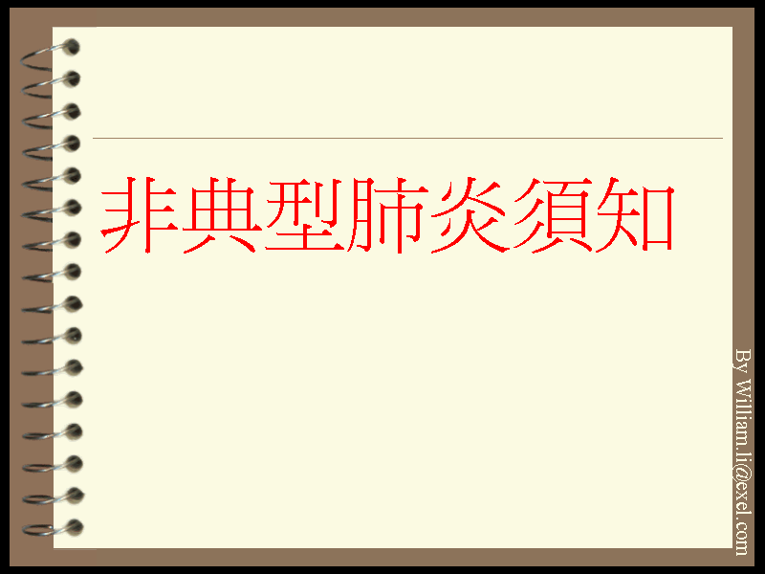

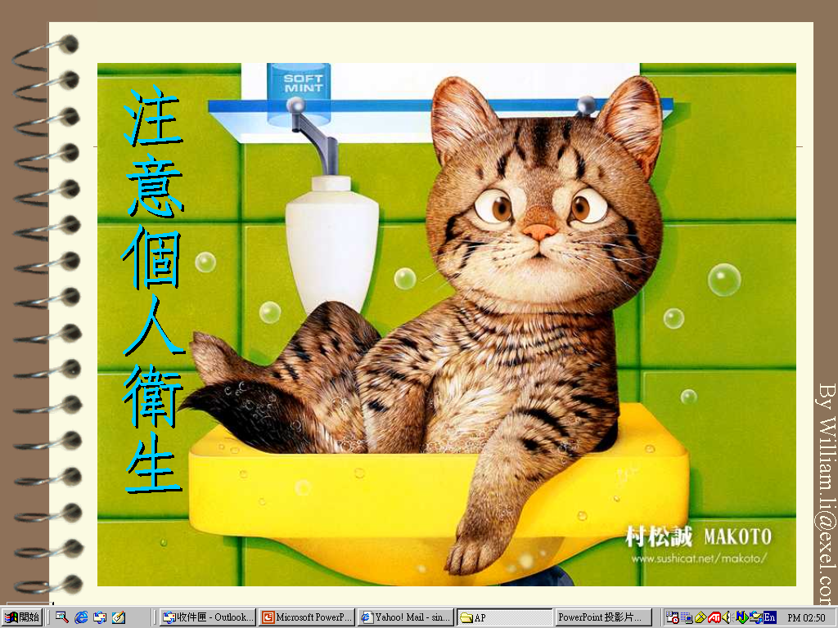
Source 7

Source 8
【明報專訊】 對於有人透過電郵及傳真散播兩份標題分別為「證實已染 SARS的醫生名單」、「可提供檢驗非典型肺炎服務的醫生名單」的虛假資料，警方商業罪案調查科已接手調查，正循「不誠實使用電腦」的調查方向，了解是否有人涉嫌觸犯刑事罪行。香港醫學會前晚發表聲明，對坊間流傳上述兩份名單深表關注，指「可提供檢驗非典型肺炎服務的醫生名單」誤導公眾，亦可能導致名單上醫生受醫務委員會紀律處分， 而「證實已染SARS的醫生名單」 內容，亦可能涉及誹謗，事實上名單上180名醫生沒有一人證實感染。

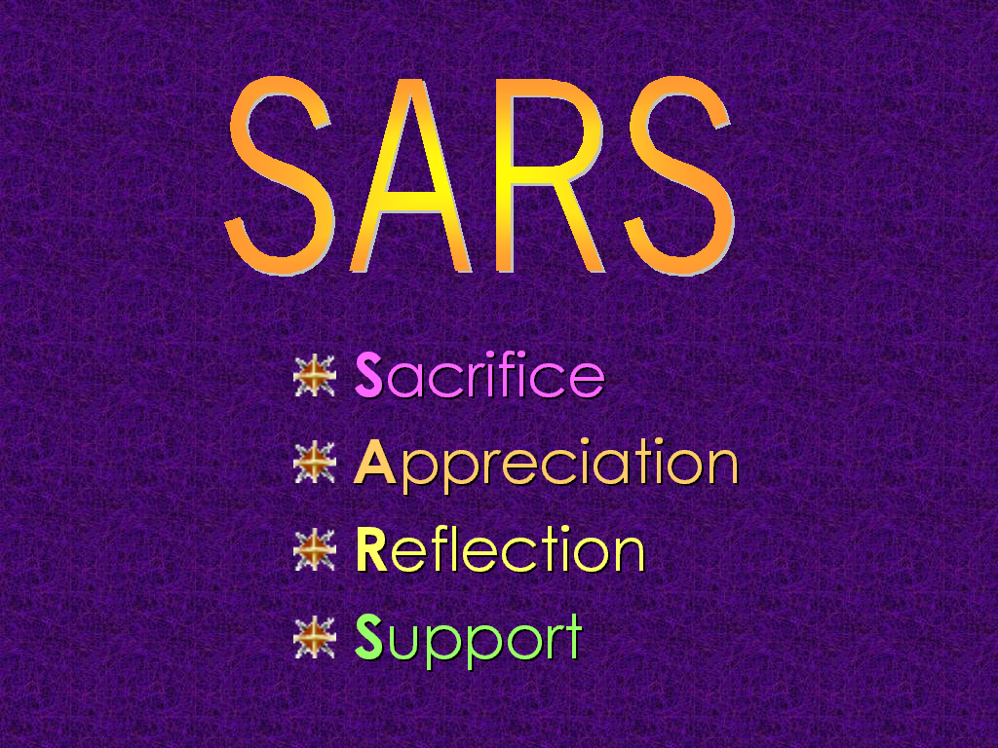
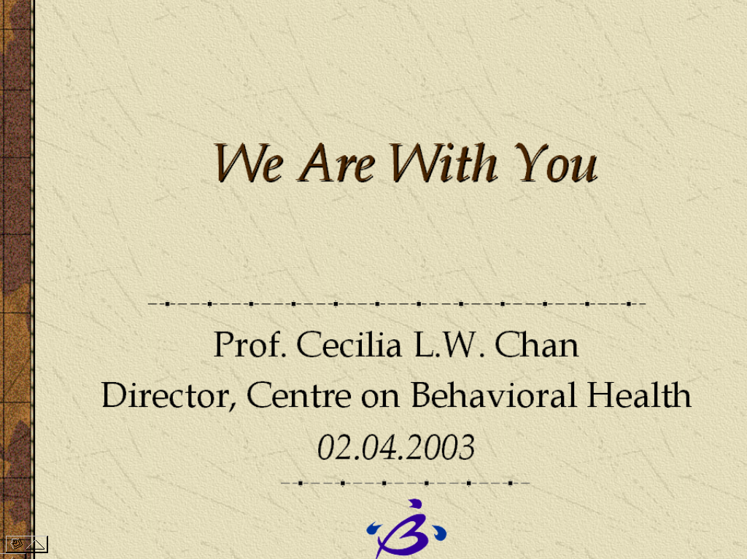
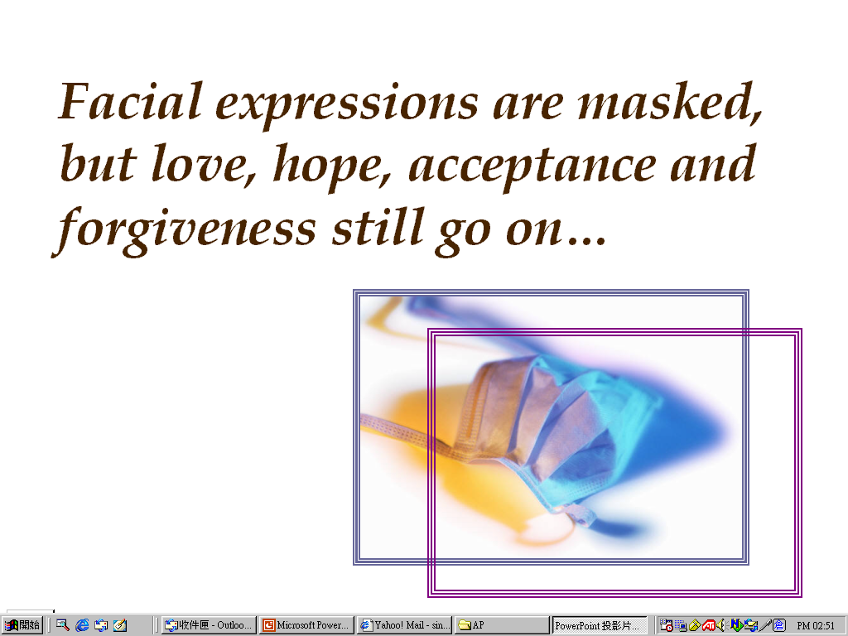
記者致電查詢謠傳中招的醫生，普通科張醫生指出，3日前從電郵收到有關名單，並赫然發現自己「榜上有名」，醫務所過去兩天幾乎每日也收到約10個電話，跟進他的「病情」。張醫生坦言，診所生意亦受到影響。
【來源：明報】
Source 9
Source 10
Do you think the mails can pass the credibility test?
Assessment Form for E-mail Credibility
 |  | Author
 | Date | Name | Reliability | Consistency  with the author’s background | Audience | Purpose | Consistency  in content | Credibility  (With reference to the table below, indicate the credibility of the source by putting ⬇ in the corresponding box)

Source 1
Source 2
Source 3
Source 4
Source 5
Source 6
Source 7
Source 8
Source 9
Source 10

⬇ | date not specified; author not specified; unclear purpose; inconsistent in content
⬇⬇ | Date and author specified; but content inconsistent with author’s status, professional position and/or character; unclear purpose; inconsistent in content
⬇⬇⬇ | Date and author specified; clear purpose; no obvious inconsistency in content
⬇⬇⬇⬇ | Date and author specified; clear purpose; content consistent with author’s status, professional position and/or character; no inconsistency in content
⬇⬇⬇⬇⬇ | Date and author specified; author renowned and of high status; clear purpose; content consistent with author’s status, professional position and/or character; content consistent and verifiable
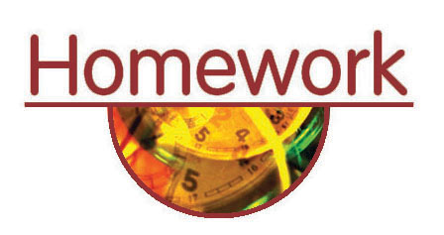

Having completed the credibility test, which e-mail(s) would you choose to share with your friends? Why?

_____________________________________________________________________

Attention

To assess the credibility of a piece of information, the list of questions in the “Five Criteria in Assessing E-mail Credibility” is but a starting point. To tell right from wrong, to discern true from fake, we have to know more, think more and experience more.

